Course Specialist Test 2 Year 12

Student name: ________________ Teacher name: ________________

Task type: Response

Time allowed for this task: ____40_______ mins

Number of questions: _____7______

Materials required: Calculator with CAS capability (to be provided by the student)

Standard items: Pens (blue/black preferred), pencils (including coloured), sharpener, correction fluid/tape, eraser, ruler, highlighters

Special items: Drawing instruments, templates, notes on one unfolded sheet of
A4 paper, and up to three calculators approved for use in the WACE examinations

Marks available: _41_____ marks

Task weighting: _10___%

Formula sheet provided: Yes

Note: All part questions worth more than 2 marks require working to obtain full marks.

Q1 (2, 2 & 3 = 7 marks) (3.2.1-3.2.3)
Consider the functions and .
- State the natural domain and range of .

Solution
Specific behaviours
states domain
states range

- Does exist over the natural domain of ? Explain.

Solution
To exist therefore does not exist over natural domain

Specific behaviours
states does not exist with any reason
reason shows relevant domain and range

- State the rule and natural domain and range of .

Solution
Specific behaviours
states rule
states domain which excludes x=4
states range with correct endpoints inequalities of excluded interval

Q2 (3, 3, 1 &2 = 9 marks) (3.2.4)
Consider the function with domain .

- Sketch the inverse function on the axes below.

Solution
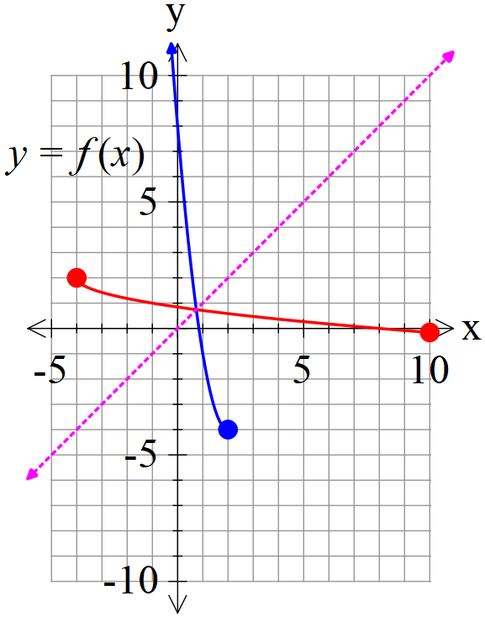

Specific behaviours
appears to be reflected in y=x
shows pts (-4,2) & (8,0) on iverse
correct domain and range

- Determine the inverse function stating its domain. (Show all working)

Solution
Specific behaviours
shows the interchange of y & x or shows how x is made the subject of rule
states inverse rule with correct sign
states domain

- Determine

Solution
Specific behaviours
states x

- Determine when exactly.

Solution
Meets on line y=x
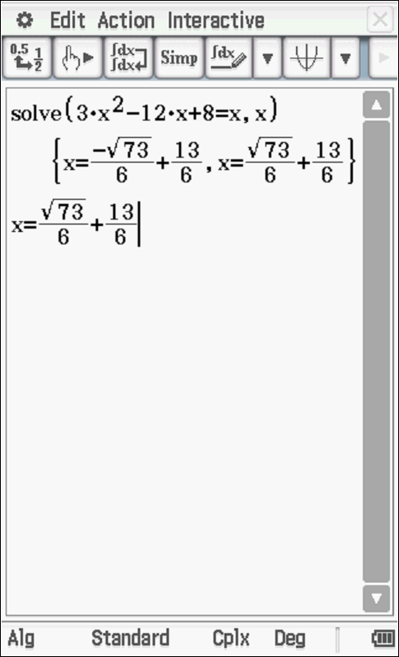
Discard second answer as outside domain of f

Specific behaviours
sets up an equation to solve for x
solves for one value of x exactly

Q3 (3 marks) (3.2.6)
Consider the inequality is only true for with a constant.
Determine the value of .

Solution
Specific behaviours
uses midpoint of solution interval
rearranges inequality to identify centre in terms of x
states correct value of constant

Q4 (3 & 3 = 6 marks) (3.2.7)
Consider the following function .

- Sketch on the axes below.

Solution
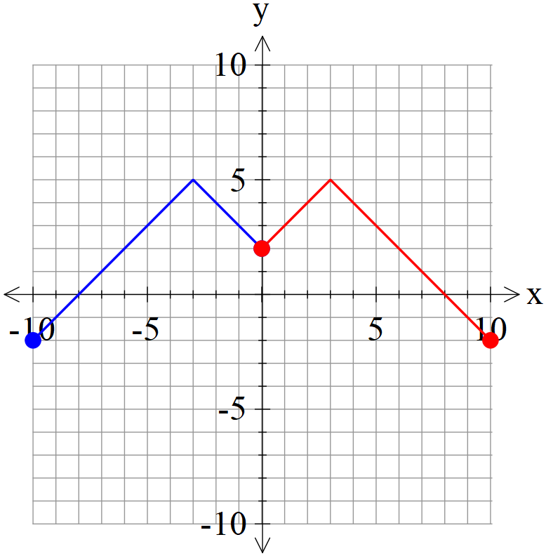

Specific behaviours
appears to reflect left side
correct x intercepts
y intercept and drawn with correct domain

- Sketch on the axes below.

Solution
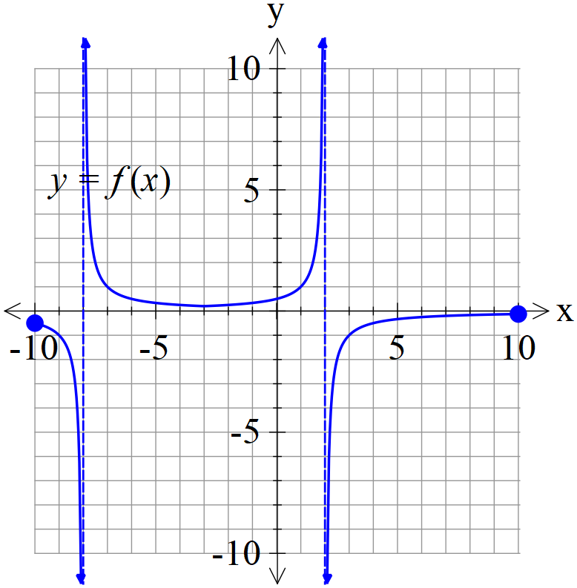

Specific behaviours
both asymptotes shown
y intercept correct with y endpoints
shape in all 3 section

Q5 (3 & 3 = 6 marks) (3.3.3-3.3.6)
Consider two rockets A&B, moving with constant velocities such that at time hours their positions and velocities are as follows:
- Determine the time and distance of their closest approach.

Solution
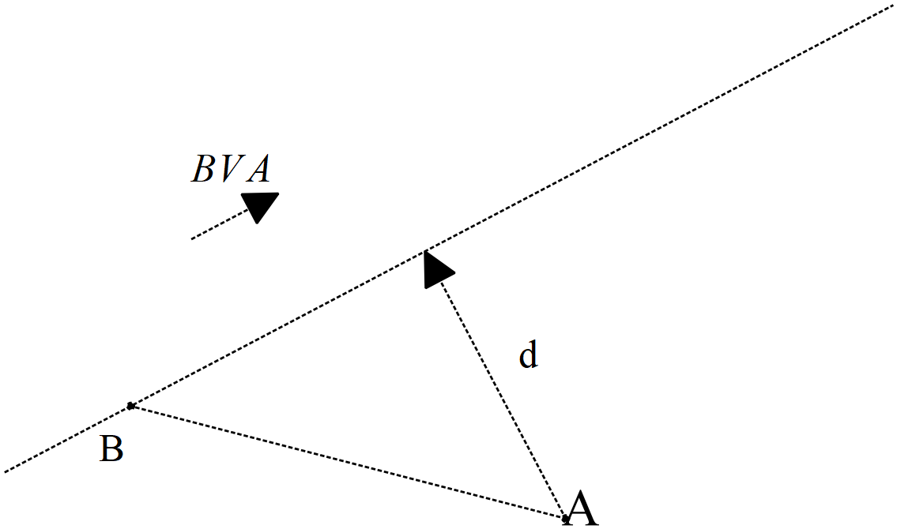

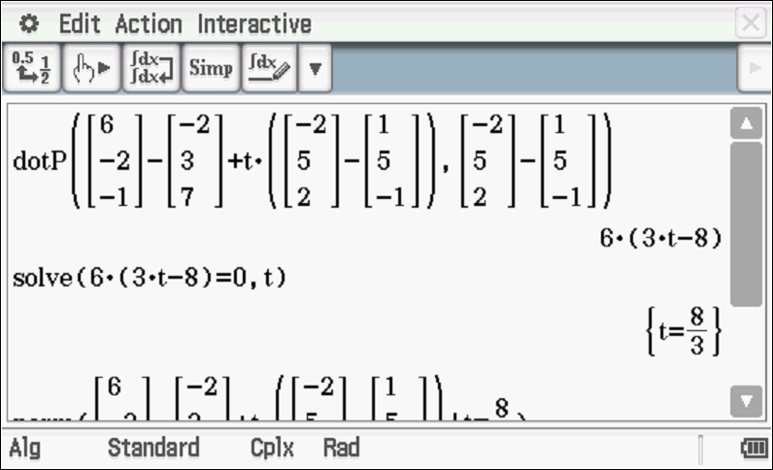
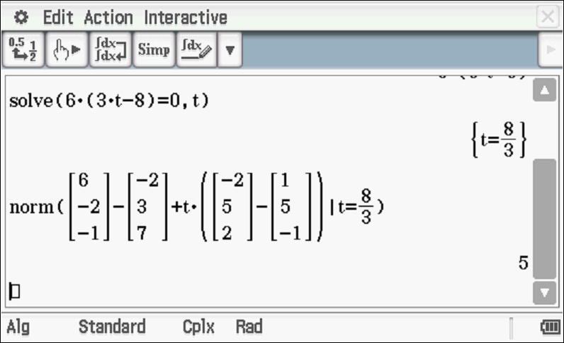
Distance=5 mins
Specific behaviours
uses displacement vector with dot product OR calculus with separation vector
states time of closest approach (no need for units)
states distance approx. or exact (no need for units)

- Given that the rockets leave smoke trails that stays in the air for a long period of time, determine if the smoke trails cross at all and if they do, its position in space. Justify.

Solution
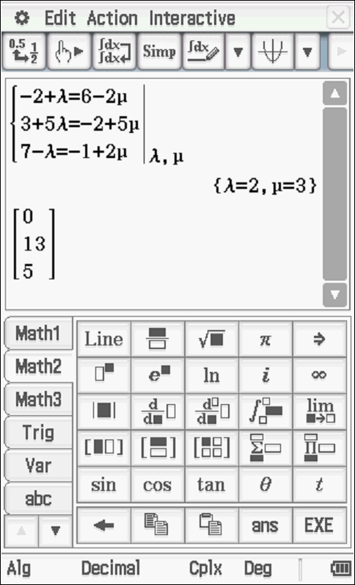

Specific behaviours
uses lines with different parameters
shows solution to stated simultaneous equations(all 3) with values of parameters
states point of intersection of smoke trails

Q6 (6 marks) (3.3.4, 3.3.6)
Consider the line and the sphere with a constant.
Determine the value(s) of , to one decimal place, such that:
- The line is a tangent to sphere.
- The line meets the sphere in two places.
- The line misses the sphere completely.

Solution

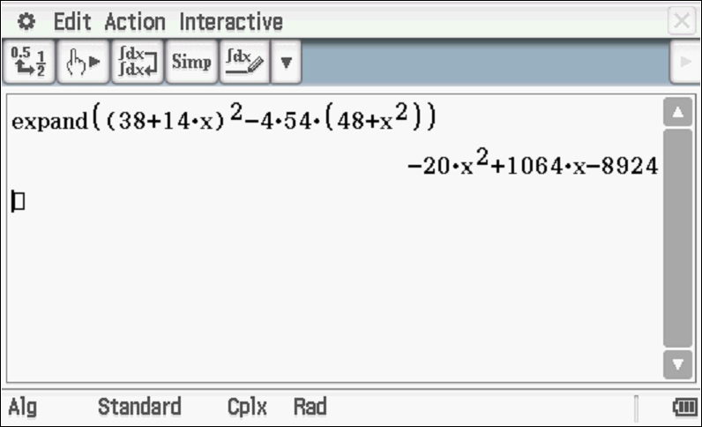
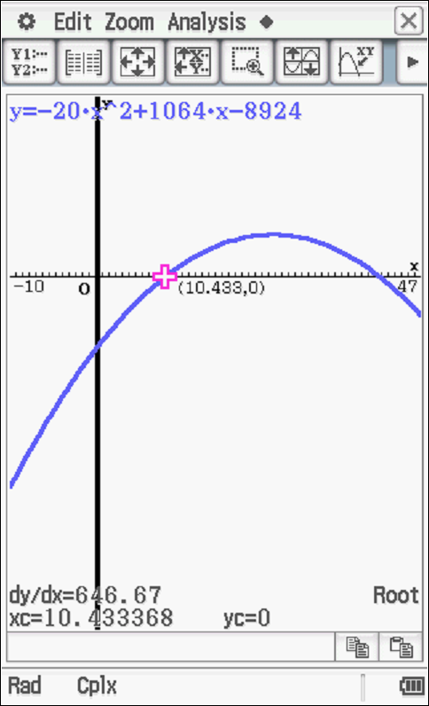
Tangent
Two places
No intersection
Specific behaviours
subs line into sphere equation
sets up equation for
sets up a quadratic equation for in terms of
determines expression for discriminant in terms of and solves when
states values for one of the three scenarios with reasoning (no need for rounding)
states values for all three scenarios with reasoning for each (no need for rounding)
NOTE: No follow through if mistake makes problem easier.

Q7 (4 marks) (3.1.4)
The solutions to the complex equation are plotted in the complex plane. ( is an integer & is a complex constant). Exactly four of the solutions are plotted in the second quadrant,, and no more. Of these four solutions, the smallest argument is .
Determine all possible values of .

Solution
Consecutive roots arguments separated by
Four arguments are:

Specific behaviours
uses additions of
sets up equation for lower boundary for
sets up equation for upper boundary for
states all allowed integer values for

